**Software Requirements Specification**

**for**

**Machine Learning in Diabetes**

**Version 1.0**

**Prepared by**

**Bhavana M**

**1**.**Introduction**

**Document Purpose:** To detect if the person is suffering from diabetes using glucose and blood pressure as features and Diabetes as label.

**Product Scope:** helps to check if a person has diabetics

**Intended Audience:** Developer, Tester

**2**.**Overall Description**

**Product Overview:**

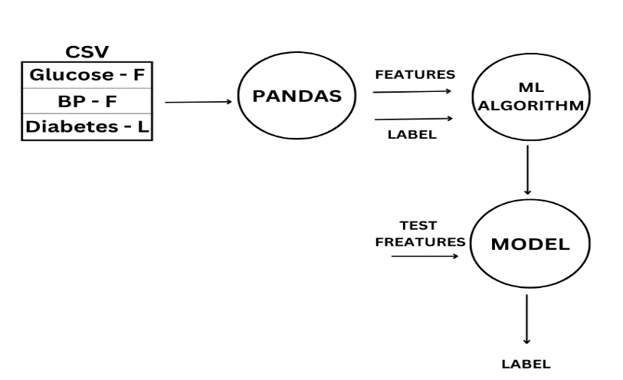

**Product Functionality:**

R1: Download data in CSV format

R2: Using pandas extract features and label from CSV file

R3: Build ML Model using ML Algorithm

R4: Predict and analyze

**3**.**Functional Requirements**

Using pandas extract features and label from CSV file

Build ML Model using ML Algorithm

**4**.**Other Requirements** N/A